Battle Plan for Conversions
February 18th, 2022

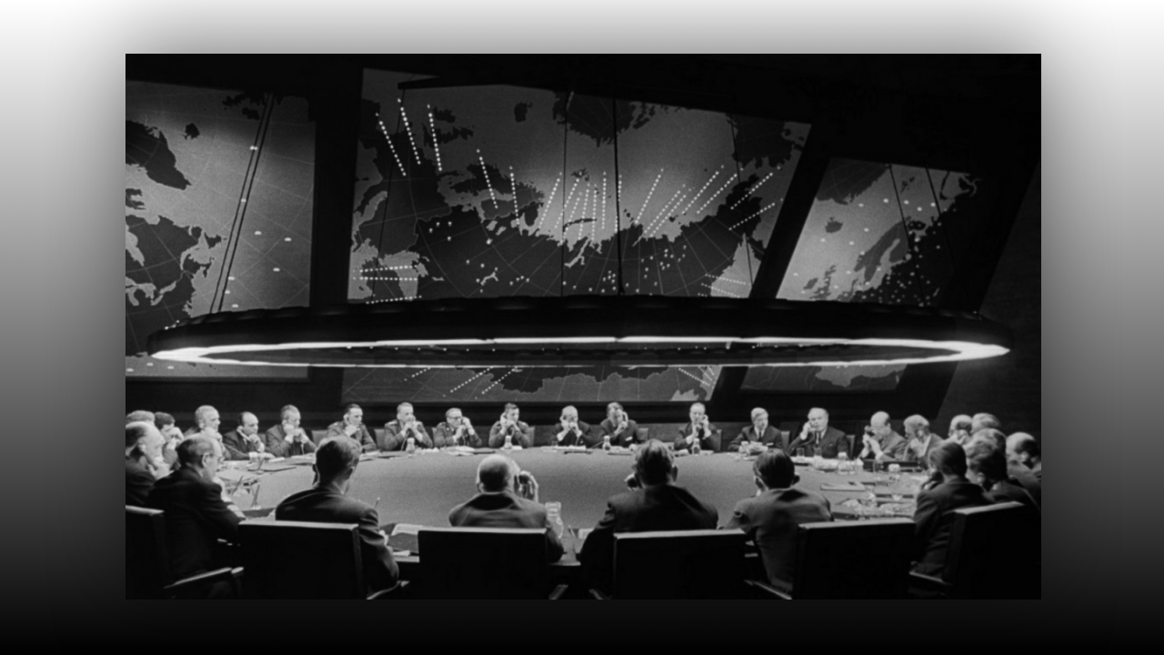
Lord Jesus, most merciful Savior, we pray that all the sheep who have strayed from Your fold may be converted to You and will glorify You for all eternity. Amen.

Mother Clare began, “What is on your heart Mother?”

“I want to see you get well, but this sickness is an abundant offering, for so many situations that are to come. You cannot be there on the front lines, but you can quietly and submissively offer these sufferings, which I know are truly hard for you.”

“Blessed Mother, you can make us stronger.”

“Indeed, and I do sweet child. Show much gratitude for the washing away of your sins. Be ever so grateful that this has so readily been extended to you. Tuck this in your heart, guard it from defilement and do the right thing from moment to moment. In short Clare, hold onto this grace and keep yourself scrupulously clean. Your prayers too will increase in effectiveness. Thank you for being willing to shoulder this burden, I know it is not easy.”

“Oh Mother, it’s the least I can do. It is such a small sacrifice.”

“It is, but when you handle those well, greater things are asked of you. What is coming will bring the people of Europe to their knees, it will lead to the Ezekiel 38 war. What dramatic times you are living in, you have no idea. Some have been very blessed and lived and died only during peace time. For others, it will be a horrendous shock if they have never been in the military. Many will return to prayer and ask God for His protection. However, the wicked will only become more wicked.

“You must hold up your nation with prayer. Many things the enemy wants to do here will not be accomplished, but it will take all of your prayers. You are the fortification for this area, it is your prayers that will bring protection, as well as conversions. His heart is still set on liberating the victims of Penasco and the surrounding areas.

“You need to rest and not be so anxious to get messages out. You have helpers you know. The enemy wants to take you out, but this will not happen. Rest, my daughter and all my children who are weary, and be still before My Son. Cherish this time with your spouse beloved ones.”

As we were praying the Rosary, Brother John was leading the decade and had just said the words “call to conversion”. Right then, Mother Elisabeth saw Jesus standing at a table pouring over what looked like blueprints of a plan, and a pure, white lamb was laying down on the other side of the table. She asked Jesus, “What are you looking at Lord?” And He replied, “A battle plan…..a battle plan for conversions.”

Dear Family, let us continue to pray for a tidal wave of repentance for sinners, the conversion of the unsaved and the conversion of our enemies as we are end time ministers in our Lord’s army.

